Sample Screens and Reports

## Aggregate Photo Analyzer

Mason Howard, Cameron Lowry, Katy Wanger

# Data Files

* Stored as attributes in MySQL database:
  + Path to picture file: VARCHAR(255)
  + Size (MB): Unsigned SMALLINT
  + Name : VARCHAR(100)
  + Resolution
    - Width: Unsigned SMALLINT
    - Length: Unsigned SMALLINT
  + Orientation: ENUM(“Portrait”,”Landscape”,”Unknown”)
  + Manufacturer:ENUM(“Canon”,”Casio”,”Epson”,”Fijifilm”,”GoPro”,”HP”,”Kodak”,”Panasonic”,”Polaroid”,”Nikon”,”Samsung”,”Sony”,”Other”)
  + Model: VARCHAR(26)
  + Focal Length (mm): Unsigned SMALLINT
  + Exposure Time (seconds): DECIMAL(5,2)

*(precision, scale)- 5 significant digits, 2 digits past decimal point*

* + Aperture (*f*/): DECIMAL(5,2)

*(precision, scale)- 5 significant digits, 2 digits past decimal point*

* + ISO*:* Unsigned SMALLINT
  + Date: DATETIME
  + File type: CHAR(3)
  + User inputted tags: VARCHAR(26)
  + Color values
    - Average Red: Unsigned TINYINT
    - Average Blue: Unsigned TINYINT
    - Average Green: Unsigned TINYINT
* Output files: Excel spreadsheets (.XLS)
* Input files: Image files (.JPG, .PNG, .PPM,.GIF)

# Sample Screen #1 –Importing Image Data

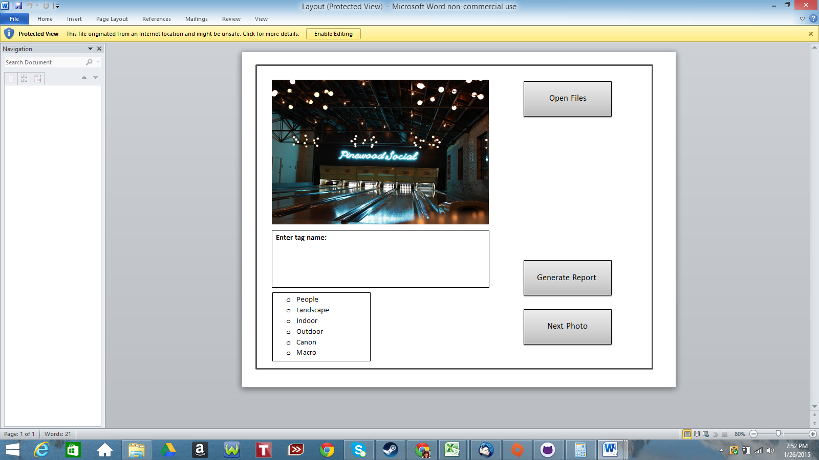

# Sample Screen #2 – Generating Reports

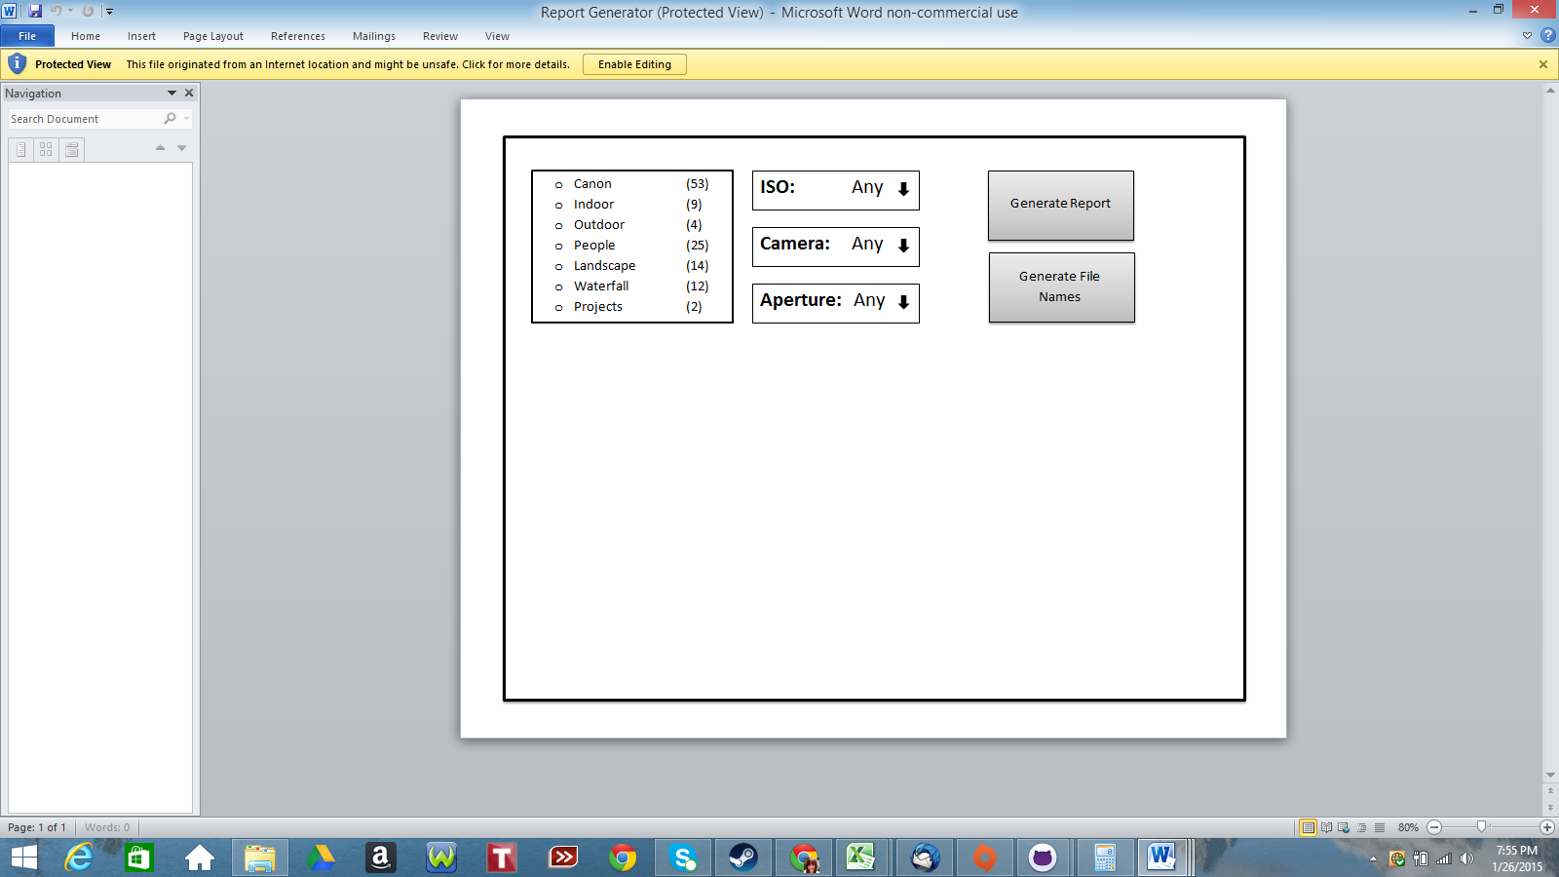

# Sample Report #1 – Statistics of Image Attributes

From SampleReport1.xls

|  |  |  |  |
| --- | --- | --- | --- |
| Report #1 – Jan. 26,2015 |  | **Number of Images** | **Percentage** |
| **Total Images** |  | 66 | 100.0% |
|  |  |  |  |
| **Tags** | Canon | 53 | 80.3% |
|  | Indoor | 9 | 13.6% |
|  | Landscape | 14 | 21.2% |
|  | Outdoor | 4 | 6.1% |
|  | People | 25 | 37.9% |
|  | Projects | 2 | 3.0% |
|  | Waterfall | 12 | 18.2% |
|  |  |  |  |
| **ISO** | 100 | 22 | 33.3% |
|  | 400 | 43 | 65.2% |
|  | 3200 | 1 | 1.5% |
|  |  |  |  |
| **Camera** |  |  |  |
|  | Canon Powershot G1 X | 53 | 80.3% |
|  | Kodak Easyshare | 13 | 19.7% |
|  |  |  |  |
| **Aperture** | f/1.4 | 13 | 19.7% |
|  | f/4 | 53 | 80.3% |

|  |  |
| --- | --- |
| **Settings** | **Image Files** |
| Tags: “Indoor” | IMG_0001 |
| ISO: Any | IMG_0002 |
| Camera: Any | IMG_0003 |
| Aperture: Any | IMG_0045 |
|  | IMG_0046 |
|  | IMG_0047 |
|  | IMG_0127 |
|  | IMG_0128 |
|  | IMG_0298 |

# Sample Report #2 – Listing of Image Files

From SampleReport2.xls

# 